Creating a new role
To create a custom role:
- Go to Settings > Site administration > Users > Permissions > Define roles.
- Click the "Add a new role" button.
- Give the role a Short name e.g. 'Parent'.The short name is necessary for other plugins in Moodle that may need to refer to the role (e.g. when uploading users from a file or setting enrolments via an enrolment plugin).
- You must provide a full name for all custom roles. If you need to name the role for multiple languages you can use multi-lang syntax if you wish.
- Give the role a description (optional).
- Select an appropriate role archetype (see below for further information).
- Select the contexts where the role may be assigned e.g. 'User' for Parent role.
- Set permissions as required.
- Scroll to the top or bottom of the page and click the "Create this role" button.

Creating a new role
- As an administrator, go to Settings > Site administration > Users > Permissions > Define roles and click the "Add a new role" button.
- Give the role a name (such as "Parent", but it can be anything appropriate, such as tutor/mentor) and assign it to the user context.
- Under the heading of Course
- Change moodle/user:viewdetails to allow - to access the student's profile
Under the heading of Users
- Change moodle/user:viewalldetails to allow - to view all aspects of the student's profile
- Change any/all of the following capabilities to allow
  - moodle/user:readuserblogs - to read the student's blog entries
  - moodle/user:readuserposts - to read the student's forum posts
  - moodle/user:viewuseractivitiesreport - to view the student's activity reports and grades
  - moodle/user:editprofile - to edit the student's profile
- Click the "Create this role" button.
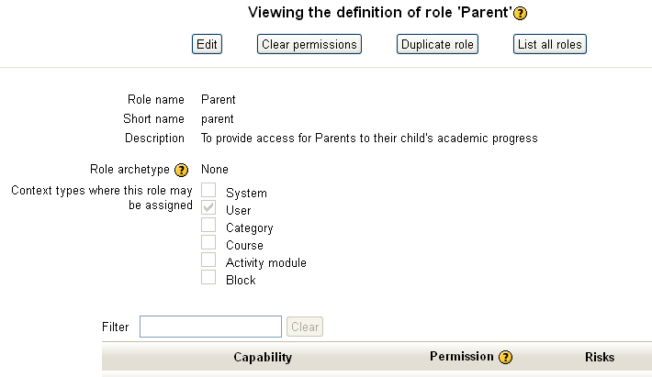
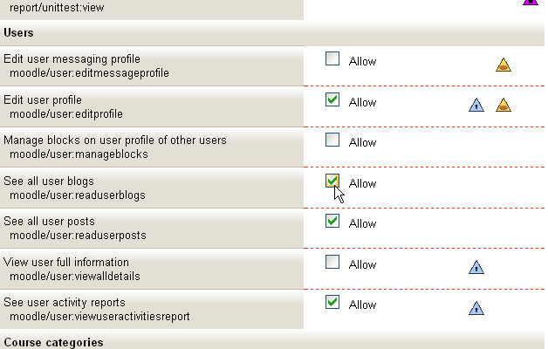
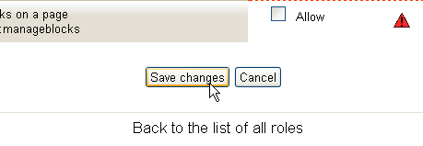

Assigning the parent to the student
- Access the child's profile page, via Site administration ► Users ► Accounts ► Browse list of users
- Go to 'Profile settings for [username]' > 'Roles' >'Assign roles relative to this user'
- Choose the role to assign i.e. Parent
- Select the parent in the potential users list and use the Add button to add it to the existing users list.
